**Why do we need plugins?**

* They can improve our work efficiency.
* They help reduce repetitive tasks, so we don't have to do the same work over and over again.
* They minimize programmer mistakes.

**Note:**

* First, never download plugins that upload your code, such as AI plugins like GitHub Copilot or similar ones.
* Second, plugins depend on what you need, so there are no strict rules.  
  Just pick the plugins you need.

**How to install plugins?**

Click setting icon in vscode then click extensions.

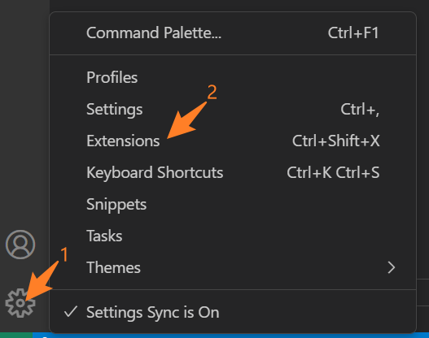***About IDE*** ***appearance***

**Material Icon Theme: Material Design Icons for Visual Studio Code**

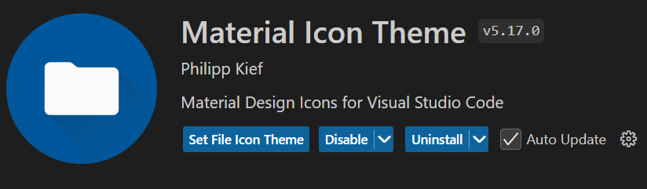

***About Code style***

**Eslint: Integrates ESLint JavaScript into VS Code.**

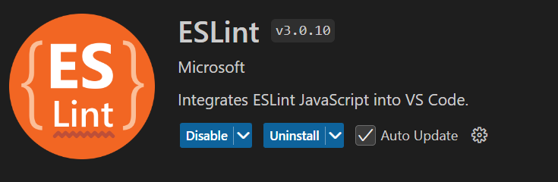

**Prettier: Format our frontend code**

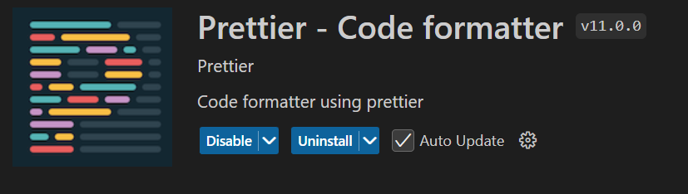

***About development Plugins***

**IntelliCode: a local AI-assisted development**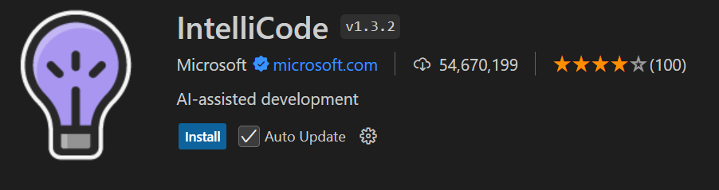

**JavaScript (ES6) code snippets: Code snippets for JavaScript in ES6 syntax** 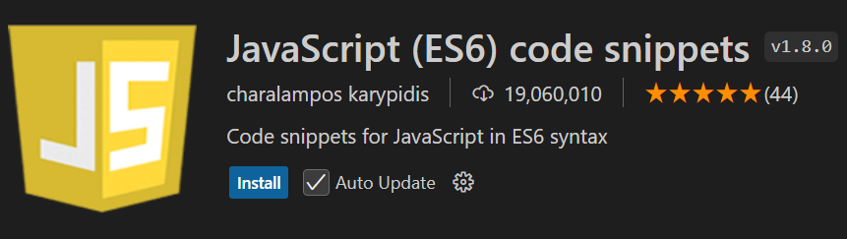

**Code Spell Checker: Spelling checker when we coding**

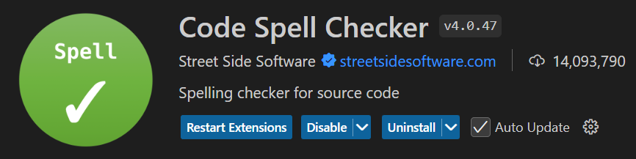

**Simple React Snippets: Simple our react snippets**

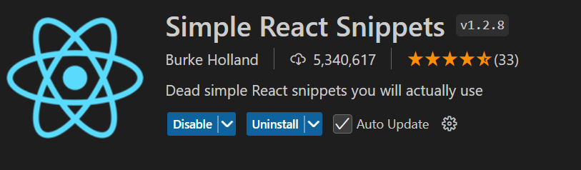

**GitLens — Git supercharged:** **Supercharge Git within VS Code**

